**Deep learning-based model for detecting 2019 novel coronavirus pneumonia on**

**high-resolution computed tomography: a prospective study**

Jun Chen#, Lianlian Wu#, Jun Zhang#, Liang Zhang, Dexin Gong, Yilin Zhao, Shan Hu,

Yonggui Wang, Xiao Hu, Biqing Zheng, Kuo Zhang, Huiling Wu, Zehua Dong, Youming Xu,

Yijie Zhu, Xi Chen, Lilei Yu*, Honggang Yu*

Department of Internal Medicine, Renmin Hospital of Wuhan University, Wuhan, China (L Wu

MD, J Zhang MD, D Gong MD, H Wu MD, Z Dong MD, Y Xu MD, Y Zhu MD, X Chen MM, Prof L Yu MD, Prof H Yu MD)

Department of Radiology, Renmin Hospital of Wuhan University, Wuhan, China (J Chen MD, L Zhang MM, Y Zhao MM)

Wuhan EndoAngel Medical Technology Company, Wuhan, China (S Hu PhD, X Hu BE, B Zheng ME, Kuo Zhang ME)

Hubei Provincial Clinical Research Center for Digestive Disease Minimally Invasive Incision, Renmin Hospital of Wuhan University, Wuhan, China (L Wu MD, J Zhang MD, D Gong MD, H Wu MD, Z Dong MD, Y Xu MD, Y Zhu MD, X Chen MM, Prof H Yu MD)

Key Laboratory of Hubei Province for Digestive System Disease, Renmin Hospital of Wuhan University, Wuhan, China (L Wu MD, J Zhang MD, D Gong MD, H Wu MD, Z Dong MD, Y Xu MD, Y Zhu MD, X Chen MM, Prof H Yu MD)

Hubei Key Laboratory of Critical Zone Evolution, School of Geography and Information Engineering, China University of Geosciences (Y Wang PhD)

*Contributed equally and are joint first authors.

Correspondence to:

Prof Honggang Yu, Department of Internal Medicine, Renmin Hospital of Wuhan University. 99

Zhangzhidong Road, Wuhan 430060, Hubei Province, China. Tel: +86 13871281899, Fax: 027-88042292, E-mail: yuhonggang1968@163.com.

Prof Lilei Yu, Department of Internal Medicine, Renmin Hospital of Wuhan University. 99

Zhangzhidong Road, Wuhan 430060, Hubei Province, China. Tel: +86 15827537180, Fax:

027-88042292, E-mail: lileiyu@whu.edu.cn.

# Abstract

**Background:** Computed tomography (CT) is the preferred imaging method for diagnosing 2019

novel coronavirus (COVID19) pneumonia. Our research aimed to construct a system based on

deep learning for detecting COVID-19 pneumonia on high resolution CT, relieve working

pressure of radiologists and contribute to the control of the epidemic.

**Methods:** For model development and validation, 46,096 anonymous images from 106 admitted

patients, including 51 patients of laboratory confirmed COVID-19 pneumonia and 55 control

patients of other diseases in Renmin Hospital of Wuhan University (Wuhan, Hubei province, China) were retrospectively collected and processed. Twenty-seven consecutive patients

undergoing CT scans in Feb, 5, 2020 in Renmin Hospital of Wuhan University were prospectively

collected to evaluate and compare the efficiency of radiologists against 2019-CoV pneumonia

with that of the model.

**Findings:** The model achieved a per-patient sensitivity of 100%, specificity of 93.55%, accuracy

of 95.24%, PPV of 84.62%, and NPV of 100%; a per-image sensitivity of 94.34%, specificity of 99.16%, accuracy of 98.85%, PPV of 88.37%, and NPV of 99.61% in retrospective dataset. For 27

prospective patients, the model achieved a comparable performance to that of expert radiologist.

With the assistance of the model, the reading time of radiologists was greatly decreased by 65%. **Conclusion:** The deep learning model showed a comparable performance with expert radiologist,

and greatly improve the efficiency of radiologists in clinical practice. It holds great potential to

relieve the pressure of frontline radiologists, improve early diagnosis, isolation and treatment, and

thus contribute to the control of the epidemic.

**Keywords:** 2019 novel coronavirus pneumonia, Deep learning, Computed tomography

# Introduction

In December 2019, a new coronavirus infection disease (hereinafter referred to as COVID-19) was

first reported in Wuhan. Subsequently, the outbreak began to spread widely in China and even

abroad.[1-3]

The clinical manifestations of the COVID-19 pneumonia is complicated and could be

characterized as fever, cough, myalgia, headache, and gastrointestinal symptoms onset.[4] Although the nucleic acid detection was considered determinant for identifying the COVID-19

infection and more rapid detection kit for the novel coronavirus has come into mass production,

computed tomography (CT) scan is still the most efficient modality for detecting and evaluating

the severity of pneumonia.[5] An update series demonstrate that CT findings were positive in all 140 laboratory-confirmed COVID-19 patients, even in the early stage.[4,6] In the fifth version of

diagnostic manual of COVID-19 launched by the National Health and Health Commission of China, the radiographic characteristics of pneumonia was included the clinical diagnostic standard

in Hubei Province.[7] Subsequently, 14,840 new cases of COVID-19 were reported within one

day on Feb 13, 2020 in Wuhan, including 13332 cases of clinical diagnoses.[8] This highlighted

the importance of CT in the diagnosis of COVID-19 pneumonia.

Due to the outbreak of the COVID-19, thousands of patients waited in line for CT

examination in the designated fever outpatient hospital at Wuhan and other cities. As of Feb 14,

there are 5,534 suspected cases, 38,107 confirmed patients receiving treatment in hospital, and 77,323 cases under medical observation in Hubei province.[9] Most of them need to undergo CT

examination, however, there are less than 4,500 radiologists in cities of Hubei according to the

China Health Statistical Yearbook (2018).[10] Meanwhile, because the lung infection foci are small in the early stage of the COVID-19 infection, thinner layer (2.5mm, 1.25mm or even 0.625mm) scanning were usually needed instead of conventional CT scan (5 mm) for diagnosis,

which would be more time-consuming. All these made radiologists overloaded, delay the

diagnosis and isolation of patients, affect patient’s treatment and prognosis, and ultimately, affect

the control of COVID-19 epidemic.

Deep learning, an important breakthrough in the domain of AI in the past decade, has huge

potential at extracting tiny features in image analysis.[11] Our group also succeeded in recruiting

this technique in minor lesion detection and real-time assistance to doctors in gastrointestinal

endoscopy.[12-16]

In the present research, we construct and validate a system based on deep learning for

identification of viral pneumonia on CT. Our model has comparable performance with expert

radiologist, but take much less time.

# Method

**Patients**

We first retrospectively collected 46,096 anonymous images from 106 admitted patients, including 51 patients of laboratory confirmed COVID-19 pneumonia and 55 control patients of other

diseases in Renmin Hospital of Wuhan University (Wuhan, Hubei province, China) for model

development. The patients’ CT scan images and reports, history, clinical manifestations, physical

findings, and viral pathogen results were all collected. For prospective patients, 27 consecutive

patients undergoing CT scans were enrolled in the designated CT rooms in Feb 5, 2020 in Renmin

Hospital of Wuhan University.

This study was approved by the Ethics Committee of Renmin Hospital of Wuhan University. Written informed consent was provided by all prospective participants. Because of virus

contamination, the signed informed consents were carefully sealed and kept in the specific place

according to the Law of the People's Republic of China on Infectious Disease Prevention and Control.[17] For patients whose CT scans were stored in the retrospective databases, informed

consent was waived by the Ethics Committee.

**Diagnostic testing for COVID-19**

Patient's respiratory secretions were collected and transferred to a sterile test tube with a virus

transport medium. Fluorescent RT-PCR analysis of samples was performed using the COVID-19

nucleic acid detection kit developed by Shanghai Geneodx Biotechnology Co., Ltd. This detection

kit was approved by the US National Drug Administration (NMPA) on January 26, 2019 and

recommended by the Centers for Disease Control and Prevention (CDC).[18] The rapid,

high-precision COVID-19 detection kit greatly accelerated the confirmation of human COVID-19

infection.

**Datasets**

As shown in **Figure 1**, a total of 46,096 CT scan images from 51 COVID-19 pneumonia patients

and 55 control patients of other disease were collected for developing the model to detect COVID-19 pneumonia. After filtering those images without good lung fields, 35355 images were

selected and split into training and retrospectively testing datasets. Enrolled images in training

dataset covered almost all common CT features of COVID19 pneumonia, as presented in **Figure 2.**

Three radiologists with more than 5 years of clinical experience labelled infection lesions of COVID-19 pneumonia patients in training dataset, and selected images containing COVID19

pneumonia lesions in testing set, and their labels were combined by consensus. For prospectively

testing the model, 13,911 images of 27 consecutive patients undergoing CT scans in Feb 5, 2020

in Renmin Hospital of Wuhan University were further collected. All CT scans were obtained in Renmin Hospital of Wuhan University. The instruments used in this study included Optima CT680, Revolution CT and Bright Speed CT scanner (all GE Healthcare).

**Training algorithm**

UNet++, a novel and powerful architecture for medical image segmentation was implemented to

develop the model.[19,20] We first trained UNet++ to extract valid areas in CT images using 289

randomly selected CT images and tested it in other 600 randomly selected CT images. The

training images were labelled with the smallest rectangle containing all valid areas by researchers.

The model successfully extracted valid areas in 600 images in testing set with an accuracy of 100%. For detecting suspicious lesions on CT scans, 691 images of COVID-19 pneumonia

infection lesions labelled by radiologists and 300 images randomly selected from patients of

non-COVID-19 pneumonia were used. Taking the raw CT scan images as input with a resolution

of 512×512, and the labelled map from the expert as output, UNet++ was used to train in Keras in

an image-to-image manner. The suspicious region was predicted under a confidence cutoff value

of 0.50, and a prediction box pixel of over 25. The training curves of UNet++ for extracting valid

areas and detecting suspicious lesions in CT images were shown in **Supplementary Figure 1** and

**Supplementary Figure 2**, respectively. The prediction schematic of the model was shown in **Figure 3**. Raw images were firstly input into the model, and after processing of the model,

prediction boxes framing suspicious lesions were output. Valid areas were further extracted and

unnecessary fields were filter out to avoid possible false positives. To predict by case, a logic

linking the prediction results of consecutive images was added. CT images with the above

prediction results were divided into four quadrants, and results would be output only when three

consecutive images were predicted to have lesions in the same quadrant.

**Testing of the model in retrospective data**

To evaluate the performance of the model on CT scan images, five metrics including the accuracy,

sensitivity, specificity, PPV and NPV were calculated as follows: accuracy = true predictions/total

number of cases, sensitivity = true positive/positive, specificity = true negative/negative, positive

prediction value (PPV) = true positive/(true positive + false positive), negative prediction value (NPV) = true negative/(true negative + false negative). The “true positive” is the number of

correctly predicted COVID-19 pneumonia cases/images, “false positive” is the number of

mistakenly predicted COVID-19 pneumonia cases/images, “positive” is the number of

cases/images of COVID-19 pneumonia patients, “true negative” is the number of correctly

predicted non-COVID-19 pneumonia cases/images, “false negative” is the number of mistakenly

predicted non-COVID-19 pneumonia cases/images and ‘negative’ is the number of

non-COVID-19 pneumonia cases/images enrolled. For image-based metrics, 636 images

containing infection lesions identified by radiologists among 11 patients of COVID-19 pneumonia

were used as the positive sample, and 9369 CT scan images from 31 patients of non-COVID-19

pneumonia were used as the negative sample.

**Evaluating the efficiency of radiologist in traditional way**

To evaluate the performance and cost of time of radiologist against 2019-CoV pneumonia,

prospectively consecutive patients undergoing CT scans were enrolled in the designated CT rooms

in Feb 5, 2020 in Renmin Hospital of Wuhan University. An expert radiologist was required to

read all CT images of enrolled patients using the working computer, and determine if each patient

has viral pneumonia. The research assistant used a stopwatch to record the expert’s reading time.

The expert radiologist was associate chief physician of the Radiology Department of Renmin Hospital of Wuhan University, with clinical experience of 30 years, and independently diagnosed

about 300 viral pneumonia. Hospitalized viral pneumonia cases judged by radiologists were all

diagnosed using COVID-19 nucleic acid detection kit to confirm COVID-19 infection. The

computed radiography imaging system used by the radiologist was VisionPACS (Intechhosun, Being, China).

**Comparison between the model and radiologist in prospective data**

The CT scan images of the prospective patients as above were collected and imported into the

model for prediction. The model’s performance and cost of time were compared with that of the

expert radiologist. Inconsistent results between the expert and model were reviewed by three

radiologists, including the expert and other two radiologists, senior staff members of the

Radiology Department of Renmin Hospital of Wuhan University, with clinical experience about 10 years, and independently diagnosed about 150 viral pneumonia.

**Evaluating the efficiency of radiologist with the assistance of AI**

To evaluate the performance and cost of time of radiologist against 2019-CoV pneumonia with the

assistance of our model, the prediction results of the model (whether a patient has viral pneumonia,

and labels marking lesions) were copied to the working computer in the designated CT rooms. After 10 days of wash out period (in Feb 16, 2020), the same expert radiologist was required to

re-read all CT images of 27 prospective patients using the working computer where results of the

model could be viewed, and determine if each patient has viral pneumonia. The research assistant

used a stopwatch to record the expert’s reading time again. Hospitalized viral pneumonia cases

judged by radiologists were all diagnosed using COVID-19 nucleic acid detection kit to confirm

COVID-19 infection. The computed radiography imaging system used by the radiologist was VisionPACS (Intechhosun, Being, China).

**Statistical analysis**

A two-tailed paired Student's t test with a significance level of 0.05 was used to compare

differences in the cost time of the model and radiologist.

**Role of the funding sources**

The funder of the study had no role in study design, data collection, data analysis, data

interpretation, or writing of the report. The corresponding author had full access to all the data in

the study and had final responsibility for the decision to submit for publication.

# RESULTS

**Patients**

The baseline characteristics and CT findings of 51 patients of 2019-CoV pneumonia and 55

control patients in retrospective dataset were shown in **Table 1** and **Table 2**, respectively. Baseline

characteristics were comparable between training and testing datasets. The 31 control patients in

retrospective testing dataset include 2 lung cancer, 4 tuberculosis, 2 bronchiectasis, 2 nonviral

pneumonia, 1 lung bullae and 20 with no obvious finding in CT scan.

**Table 1.** Clinical characteristics of enrolled patients of COVID19 pneumonia

|  |  |  |  |  |  |  |
| --- | --- | --- | --- | --- | --- | --- |
|  | **All patients (n=51)** | | **Training set (n=40)** | | **Testing set (n=11)** | |
| Age, years, median (IQR) | 52 (38, 69) | | 54.5 (41.5, 71.25) | | 42 (34.5, 65.5) | |
| Sex, n (%)  Men | 18 (35.3) | | 11 (27.5) | | 7 (63.6) | |
| Women | 33 (64.7) | | 29 (72.5) | | 4 (36.4) | |
| Presenting symptoms and signs onset, n (%) |  | |  | |  | |
| fever |  | 28 (54.9) |  | 21 (52.5) |  | 7 (63.6) |
| cough | 27 (52.9)  7 (13.7)  6 (11.8)  10 (19.6)  12 (23.5)  3 (5.9)  6 (11.8) | | 20 (50)  6 (15)  6 (15)  8 (20)  10 (25)  2 (5)  6 (15) | | 7 (63.6) | |
| Chest tightness or pain | 1 (9.1) | |
| dyspnea | 0 | |
| Muscle soreness | 2 (18.2) | |
| Expectoration | 2 (18.2) | |
| Headache | 1 (9.1) | |
| Digestive symptoms | 0 | |
| CT findings, n (%) |  | |  | |  | |
| Unilateral pneumonia | 18 (35.3) | | 13 (30) | | 5 (45.5) | |
| bilateral pneumonia | 33 (64.7) | | 27 (70) | | 6 (54.5) | |
| Multiple mottling and ground-glass opacity | 16 (31.4) | | 13 (32.5) | | 3 (27.3) | |

**Table 2.** Clinical characteristics of enrolled control patients.

|  |  |  |  |  |  |
| --- | --- | --- | --- | --- | --- |
|  | **All patients (n=55)** | | **Training set (n=24)** | **Testing set (n=31)** | |
| Age, years, median (IQR) | 48(34.5, 55) | | 50.5 (38.25, 55.25) | 47 (34.5, 54.5) | |
| Sex, n (%)  Men | 31（56.36） | | 12 (50) | 19 (61.29) | |
| Women | 24（43.64） | | 12 (50) | 12 (38.71) | |
| CT examination indications, n (%) |  | |  |  | |
| Viral pneumonia to be discharged |  | 7（12.73） | 0（0） |  | 1（3.23） |
| Pulmonary bullae to be discharged | 2（3.64）  1（1.82）  3（5.45）  7（12.7）  41（74.55） | | 2（8.33）  1（4.17）  1（4.17）  5（20.83）  15（62.5） | 0（0） | |
| Tuberculosis | 0（0） | |
| Lower respiratory infection | 2（6.45） | |
| Metastatic lung tumor to be discharged | 2（6.45） | |
| Routine examination before admission | 26（83.87） | |
| CT findings, n (%) |  | |  |  | |
| No obvious abnormality | 44（80） | | 24 | 20（64.52） | |
| Tuberculous lesion | 4（7.27） | | -- | 4（12.90） | |
| Suspected neoplastic lesions | 2（3.64） | | -- | 2（6.45） | |
| Inflammatory lesions (non-viral) | 2（3.64） | | -- | 2（6.45） | |
| Bronchiectasia | 2（3.64） | | -- | 2（6.45） | |
| Bullae of lung | 1（1.82） | | -- | 1（3.23） | |

**The performance of the model on retrospective dataset**

Among 4382 CT images from 11 patients of COVID-19 pneumonia and 9369 images from 31

control patients, the model correctly diagnosed the patients with a per-patient sensitivity of 100%,

specificity of 93.55%, accuracy of 95.24%, PPV of 84.62%, and NPV of 100%. A per-image

sensitivity of 94.34%, specificity of 99.16%, accuracy of 98.85%, PPV of 88.37%, and NPV of

99.61%. Representative images predicted by the model were shown in **Figure 4**.

**The performance of the model in consecutive prospective patients**

Twenty-seven patients were enrolled in the prospective dataset. Sixteen (59.26%) patients were diagnosed as viral pneumonia by the expert radiologist, and the other eleven patients were not. Two other radiologists reviewed the CT imaging, approved the expert’s results, and summarized

that the CT characteristics of the 11 patients not diagnosed by the expert include 5 ground glass

nodules, 3 diminutive nodules, 2 normal and 1 fibrosclerosis.

The model successfully detected all the 16 patients of viral pneumonia diagnosed by the

expert. Among the other 11 patients, 2 were also detected by the model. The predictions in one

case was fibrosclerosis lesion, and the other one was normal stomach bubble. Using results of the

radiologists as the gold standard, the model achieved a per-patient sensitivity of 100%, accuracy

of 92.59%, specificity of 81.82%, PPV of 88.89% and NPV of 100% in the 27 prospective patients. Among the 16 patients diagnosed as viral pneumonia by radiologists, 8 admitted patients were

confirmed as COVID-19 infection, and the others were outpatients that difficult to follow nucleic

acid results. The average prediction time for model was 41.34s per patient (IQR 39.76-44.48). The

performance of the model on detecting COVID-19 pneumonia was shown in **Table 3**.

**Table 3.** The performance of the deep learning model on both retrospective and prospective dataset

|  |  |  |  |  |  |  |
| --- | --- | --- | --- | --- | --- | --- |
|  | Sensitivity | Specificity | Accuracy | PPV | NPV | |
| Retrospective testing  Per patient | 100% | 93.55% | 95.24% | 84.62% | 100% | |
| Per image | 94.34% | 99.16% | 98.85% | 88.37% | 99.61% | |
| Prospective testing  (Per patient) | 100% | 81.82% | 92.59% | 88.89% | 100% | |
|  |  |

*PPV: positive prediction value, NPV, negative prediction value.

**Comparison between the efficiency of radiologist with or without the assistance of AI**

In the first time the expert radiologist read CT scan images of the 27 prospective patients, the average reading time for him to determine whether each patient has viral pneumonia was 116.12s

per case (IQR 85.69-118.17). After 10 days of wash out period, the same expert radiologist re-read

the CT images of the 27 prospective patients with the assistance of the AI model. The results for

determining whether each patient has viral pneumonia were not changed, while the average

reading time of the expert was greatly decreased by 65%. This indicates that the efficiency of

radiologist could be greatly improved with the assistance of AI.

A website has been made available to provide free access to the present model (http://121.40.75.149/znyx-ncov/index) (**Figure 5**). CT scan images could be uploaded by both

clinicians and researches as a second opinion consulting service, especially in other provinces or

countries unfamiliar with the radiologic characteristics of COVID-19. Cases of COVID-19

pneumonia were also been made available on the open-access website, which might be a useful

resource for radiologists and researchers for fighting COVID-19 pneumonia.

# DISCUSSION

As of Feb 14, 2020, the national health commission had reported 66,492 confirmed cases, 1,523 deaths and 8,969 suspected cases.[21] In the face of such large number of patients and high

contagiosity of the novel coronavirus (with an estimated reproduction number R0 of 2.2~6.47),

timely diagnosis and isolation are the keys to prevent further spread of the virus.[22-26] CT scan

is the most efficient modality for screening and clinically diagnosing COVID-19 pneumonia.[5,7] However, compared to the needs of the patients, the number of radiologists is quite small,

especially in Hubei province, China, which could greatly delay the diagnosis and isolation of

patients, affect patient’s treatment and prognosis, and ultimately, affect the overall control of COVID-19 epidemic.

Deep learning, a technology has shown great performance on extracting tiny features in

radiology data, may hold the promise to alleviate this problem.[11]Recently, Ardila D, et al

achieved end-to-end lung cancer screening on low-dose chest CT with an AUC of 94.4%.[27] Chae KJ, et al successfully used the convolutional neural network to classify small (≤2 cm)

pulmonary nodules on CT scan images.[28] However, there was rare research being conducted to

detect viral pneumonia.[11,27,28] In previous work, our group succeeded in recruiting deep

learning in minor lesion detection and real-time assistance to doctors in gastrointestinal

endoscopy.[12-16] Here, we enrolled this technique in identification of COVID-19 pneumonia in CT images. Results from both retrospective and prospective patients showed that the model was

comparable to the level of expert radiologist, and hold great potential to reduce diagnosing time. (**Figure 6**)

Early diagnosis and early isolation of suspected patients are the most important ways to

prevent the spread of epidemic.19 Due to the sudden outbreak of COVID19, the radiology

department is overloaded and patients have to wait for long times for chest CT scan, which largely

increase the risk of cross-infection. In recent days, radiologists’ daily workload is huge in Hubei

province, and a CT scan report has to be awaited several hours to achieve. Based on the number of

suspected patients and close contacts in being, radiologists in the hardest hit, Hubei province, China, may not be enough to resist the rapid spread of the virus, which holds high estimated R0 of 2.2~6.47.[23-26] It could be inferred that before radiologists fulfilling the demands of existing

patients, newly infected cases would appear, and the overall burden of radiologists is more

overwhelming like a growing snowball. Relieving the pressure of radiologists is essential for the control of virus spreading. In the present study, our model achieved a comparable performance but

with much shorter time compared with expert radiologists. It holds great potential to relieve the

pressure of radiologists in clinical practice, and contribute to the control of the epidemic.

Timely diagnosis and early treatment of infected patients is important for patients’

prognosis.[29] The fatality rate of COVID19 patients in Hubei province is significantly higher

than that of other regions, which probably due to delayed treatment and shortage of medical

resources.[8,30] Accelerating diagnosis efficiency is significant for improving patient outcomes. In the present study, our model helped expert radiologists achieve the same work with much

shorter time, which greatly accelerats the efficiency of diagnosis in clinical practice, and may

contribute to the improvement of patient outcome.

In addition to relieving radiologists’ pressure and accelerating diagnosis efficiency, artificial

intelligence also holds the potential to reduce miss diagnosis of COVID-19 patients. The lung

infection foci are sometimes mild in the early stage of the COVID-19 infection,5 and requires

careful observation under 0.625mm layer scanning. Radiologists vary in skills, and could be

affected by subjective status and outside pressure. One miss diagnosis could lead to multiple

spread. The model is highly sensitive and stable, and would never be affected by work burden and

work time. As a preliminary screening tool, it might help radiologists improve the sensitivity and

reduce miss diagnosis.

On the basis of the accuracy and efficiency of the model in detecting COVID-19 pneumonia,

a cloud-based open-access artificial intelligence platform was constructed to provide assistance for

detecting COVID-19 pneumonia worldwide. CT scan images could be uploaded freely by both

clinicians and researches as an assistant tool, especially in other provinces or countries unfamiliar with the radiologic characteristics of COVID-19. This free open-access website can read images in

batches, provide high-level auxiliary diagnostic services for different hospitals in free, and expand

the boundaries of regions and manpower. Cases of COVID-19 pneumonia were also been made

available on the open-access website, which might be a useful resource for radiologists and

researchers for fighting COVID-19 pneumonia.

In summary, the deep learning-based model achieved a comparable performance with expert

radiologist using much shorter time. It holds great potential to improve the efficiency of diagnosis,

relieve the pressure of frontline radiologists, accelerates the diagnosis, isolation and treatment of COVID19 patients, and therefore contribute to the control of the epidemic.

**AUTHORS' CONTRIBUTIONS**

YH and YL conceived and supervised the overall study. WL and GD contributed to writing of the

manuscript. YH, YL, HS and WY contributed to critical revision of the report. CJ, ZL, ZJ, GD,

WH, DZ, XY, ZY and CX contributed to collecting and analyzing the data of patients. CJ, ZL and ZY contributed to label CT images. HS, HX, ZB, ZK and WY developed the system. All authors

reviewed and approved the final version of the manuscript.

**CONFLICT OF INTEREST**

Wuhan EndoAngel Medical Technology Company collaborated in this study. Shan Hu, Xiao Hu,

Biqing Zheng, Kuo Zhang are research staffs of Wuhan EndoAngel Medical Technology Company. All authors declared no conflict of interest.

**ACKNOWLEDGEMENTS**

This work was partly supported by the grant from Novel Pneumonia Emergency Science and Technology Project of Hubei Provincial (to [Honggang Yu]), Hubei Province Major Science and Technology Innovation Project (Grant No. 2018-916-000-008 to [Honggang Yu]).

**REFERENCES**

1. Hui D S, Madani T A, Ntoumi F, et al. The continuing COVID-19 epidemic threat of novel

coronaviruses to global health-The latest 2019 novel coronavirus outbreak in Wuhan, China. *International journal of infectious diseases: IJID: official publication of the International Society for Infectious Diseases* 2020;91:264.

1. Holshue ML, DeBolt C, Lindquist S,et al. First Case of 2019 Novel Coronavirus in the United States. *N Engl J Med* 2020 Jan 31. doi:10.1056/NEJMoa2001191.
2. Rothe C, Schunk M, Sothmann P, et al. Transmission of COVID-19 Infection from an

Asymptomatic Contact in Germany. *N Engl J Med* 2020 Jan 30. doi:10.1056/NEJMc2001468.

1. Huang C, Wang Y, Li X, et al. Clinical features of patients infected with 2019 novel

coronavirus in Wuhan, China. *The Lancet* 2020 Jan 24. doi: 10.1016/S0140-6736(20)30183-5.

1. Guan H, Xiong Y, Shen N, et. Clinical and thin section CT features of patients with COVID-19 pneumonia in Wuhan. *Radiologic Practice* 2020.
2. Chen N, Zhou M, Dong X, et al. Epidemiological and clinical characteristics of 99 cases of

2019 novel coronavirus pneumonia in Wuhan, China: a descriptive study. *The Lancet* 2020 Jan 30. doi: 10.1016/S0140-6736(20)30211-7.

1. National Health and Health Commission of China. http://www.nhc.gov.cn/yzygj/s7652m/202002/e84bd30142ab4d8982326326e4db22ea.shtml
2. National Health and Health Commission of China.

http://en.nhc.gov.cn/2020-02/13/c_76512.htm

1. Health Commission of Hubei Province. http://wjw.hubei.gov.cn/fbjd/dtyw/202002/t20200216_2038684.shtml
2. China Ministry of Health. China Health Statistical Yearbook 2018. Beijing: Peking Union

Medical College Press 2018:34,42 [in Chinese]

1. Liu Y, Liu G, Zhang Q. Deep learning and medical diagnosis. *The Lancet* 2019;394(10210):

1709-1710.

1. Gong D, Wu L, Zhang J, et al. Detection of colorectal adenomas with a real-time

computer-aided system (ENDOANGEL): a randomised controlled study. *Lancet Gastroenterol Hepatol* 2020 Jan 22. doi: 10.1016/S2468-1253(19)30413-3.

1. Wu L, Zhang J, Zhou W, et al. Randomised controlled trial of WISENSE, a real-time quality

improving system for monitoring blind spots during esophagogastroduodenoscopy. *Gut* 2019;68(12):2161-2169.

1. Chen D, Wu L, Li Y, et al. Comparing blind spots of unsedated ultrafine, sedated, and

unsedated conventional gastroscopy with and without artificial intelligence: a prospective,

single-blind, 3-parallel-group, randomized, single-center trial. *Gastrointestinal endoscopy* 2020;91(2):332-339. e3.

1. Zhou J, Wu L, Wan X, et al. A novel artificial intelligence system for the assessment of bowel

preparation (with video). *Gastrointestinal Endoscopy* 2020;91(2):428-435. e2.

1. Wu L, Zhou W, Wan X, et al. A deep neural network improves endoscopic detection of early gastric cancer without blind spots. *Endoscopy* 2019;51(06):522-531.
2. The Central People’s Government of the People’s Republic of China. The Law of the People's

Republic of China on Infectious Disease Prevention and Control. http://www.gov.cn/banshi/2005-08/01/content_19023.htm

1. Centers for Disease Control and Prevention. https://www.cdc.gov/corona-virus/COVID-19/lab/rt-pcr-detection-instructions.html 19. Deng J, Dong W, Socher R, et al. ImageNet: A large-scale hierarchical image database. *In:*

*2009 IEEE Conference on Computer Vision and Pattern Recognition* 2009;p.248-255.

1. Zhou Z, Siddiquee M M R, Tajbakhsh N, et al. Unet++: A nested u-net architecture for

medical image segmentation. Springer Cham 2018;3-11.

1. The National Health and Health Commission of China. http://en.nhc.gov.cn/2020-02/07/c_76323.htm
2. Cheng V C C, Wong S C, To K K W, et al. Preparedness and proactive infection control

measures against the emerging Wuhan coronavirus pneumonia in China. *Journal of Hospital Infection* 2020.

1. Tang B, Wang X, Li Q, et al. Estimation of the Transmission Risk of the 2019-nCoV and Its

Implication for Public Health Interventions. *Journal of Clinical Medicine* 2020;9(2): 462.

1. Riou J, Althaus C L. Pattern of early human-to-human transmission of Wuhan 2019-nCoV. *bioRxiv* 2020.
2. Prasse B, Achterberg M A, Ma L, et al. Network-Based Prediction of the 2019-nCoV

Epidemic Outbreak in the Chinese Province Hubei. *arXiv* 2020.

1. Boldog P, Tekeli T, Vizi Z, et al. Risk assessment of novel coronavirus 2019-nCoV outbreaks outside China. *medRxiv* 2020.
2. Ardila D, Kiraly A P, Bharadwaj S, et al. End-to-end lung cancer screening with

three-dimensional deep learning on low-dose chest computed tomography. *Nature medicine* 2019;25(6):954-961.

1. Chae K J, Jin G Y, Ko S B, et al. Deep Learning for the Classification of Small (≤ 2 cm) Pulmonary Nodules on CT Imaging: A Preliminary Study. *Academic radiology* 2019.
2. Chen Z M, Fu J F, Shu Q, et al. Diagnosis and treatment recommendations for pediatric

respiratory infection caused by the 2019 novel coronavirus. *World Journal of Pediatrics* 2020:1-7.

1. Health Commission of Hubei Province.

http://wjw.hubei.gov.cn/fbjd/dtyw/202002/t20200215_2028355.shtml

**FIGURES**

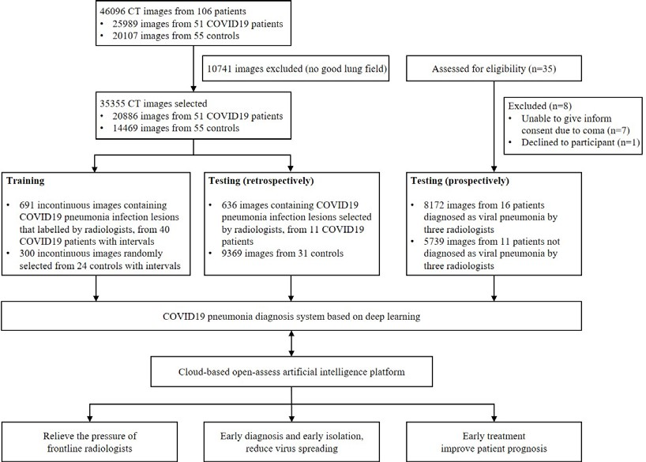

**Figure 1. Workflow diagram for the development and evaluation of the model for detecting COVID19 pneumonia.**

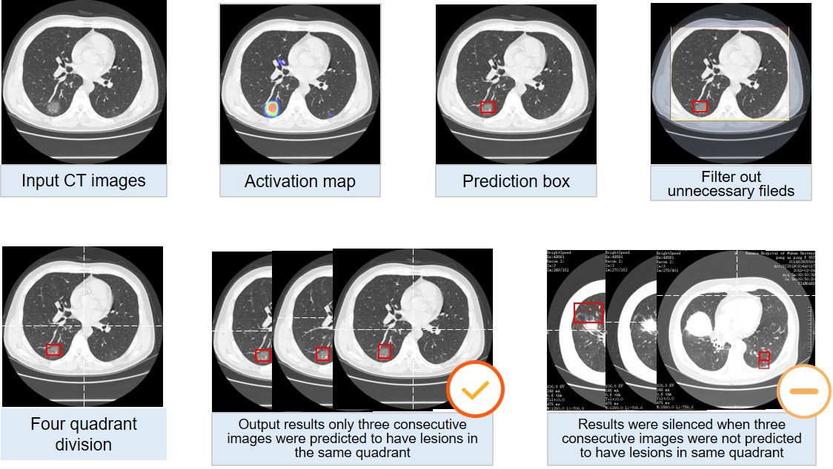

**Figure 2. Representative images of COVID19 pneumonia.** More than six common Computed

tomography (CT) features of COVID19 pneumonia were covered in selected images. 1a-1d, the

lesions were mainly ground-glass-like, with thickened blood vessels walking and including

gas-bronchial signs in 1c; 2a-2d, the lesions were mainly ground glass changes, and paving

stone-like changes were observed on 2d; 3a-3c, the lesions become solid with a large range, and

air-bronchial signs are seen inside; 4, the lesion is located in the lower lobe of both lungs, and is

mainly grid-like change with ground glass lesion; 5a-5b, the lesions are mainly consolidation; 6a-6b, the lesions are mainly large ground glass shadows, showing white lung-like changes, with

air-bronchial signs.

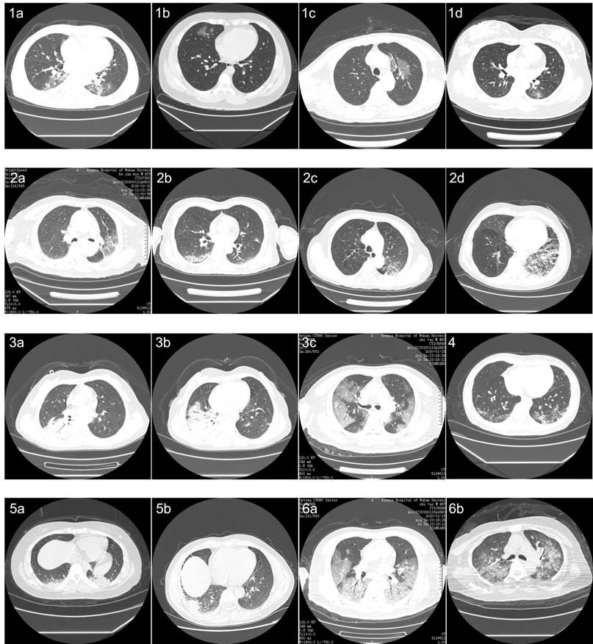

**Figure 3. Processing and prediction schematic of the model.** Raw images were firstly input into

the model, and after processing of the model, prediction boxes framing suspicious lesions were

output. Valid areas were further extracted and unnecessary fields were filter out to avoid possible

false positives. To predict by case, a logic linking the prediction results of consecutive images was

added. Computed tomography (CT) images with the above prediction results were divided into

four quadrants, and results would be output only when three consecutive images were predicted to

have lesions in the same quadrant.

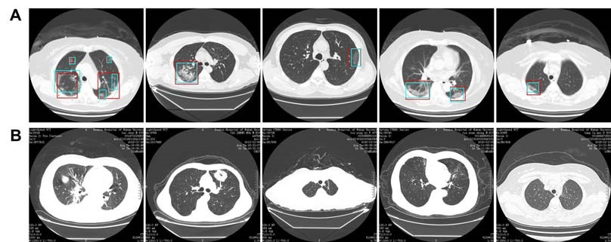

**Figure 4. Representative images of the model’s predictions.** A. Computed tomography (CT)

images of COVID19 pneumonia. The predictions between the artificial intelligence model and

radiologists were consistent. Green boxes, labels from radiologists; red boxes, labels from the

model. B. CT images of the control. The first image is an ordinary bacterial pneumonia, showing a

consolidation of the right lower lobe. The second image has a tumorous lesion in the lung,

showing a mass in the left upper lobe, with burrs seen at the edges, and showing leaf-like growth

with vacuoles inside. The third image is a secondary pulmonary tuberculosis, showing a left apical

fibrous cord. The fourth image is a bronchiectasis complicated with infection, showing

bronchodilation and expansion, cystic changes, and surrounding patches of infection. The fifth

image shows normal lungs.

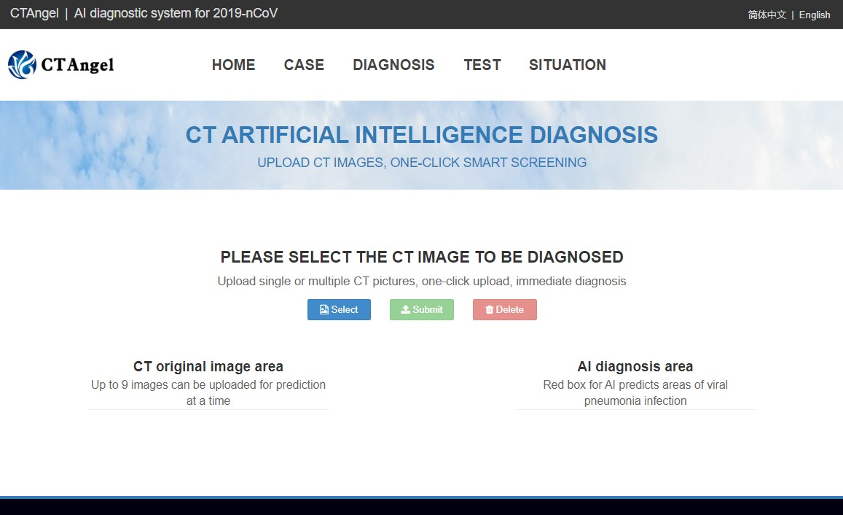

**Figure 5. Main interface of the open-access artificial intelligence platform which provides**

**fast and sensitive assistance for detecting COVID19 pneumonia.**

(http://121.40.75.149/znyx-ncov/index)

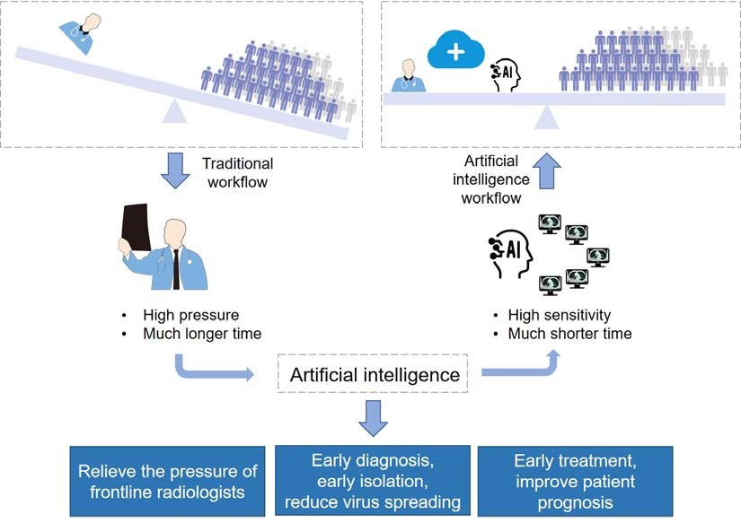

**Figure 6. Abstract diagram.** Computed tomography (CT) is the most efficient modality for

screening and clinically diagnosing COVID-19 pneumonia. However, compared to the needs of

the patients, the number of radiologists is quite small. After enrolling artificial intelligence in

identifying COVID-19 pneumonia in CT images, the efficiency of diagnosis is greatly improved. The artificial intelligence holds great potential to relieve the pressure of frontline radiologists,

accelerates the diagnosis, isolation and treatment of COVID19 patients, and therefore contribute to

the control of the epidemic.

**Supplementary Figure 1. The training curves of UNet++ for extracting valid areas in Computed tomography images.**

**Supplementary Figure 2. The training curves of UNet++ for detecting suspicious lesions in**

**Computed tomography images.**